**Industrial Internship Report on**

**”Crop and Weed Detection”**

**Prepared by**

**Srushti Sanjay Pai**

|  |
| --- |
| *Executive Summary* |
| This report provides details of the Industrial Internship provided by upskill Campus and The IoT Academy in collaboration with Industrial Partner UniConverge Technologies Pvt Ltd (UCT).  This internship was focused on a project/problem statement provided by UCT. We had to finish the project including the report in 6 weeks’ time.  My project was crop and weed detection model using YOLOV3 on agricultural image data.  This internship gave me a very good opportunity to get exposure to Industrial problems and design/implement solution for that. It was an overall great experience to have this internship. |

**TABLE OF CONTENTS**

1 Preface 3

2 Introduction 6

2.1 About UniConverge Technologies Pvt Ltd 7

2.2 About upskill Campus 7

2.3 Objective 7

3 Problem Statement 8

4 Existing and Proposed solution 8

5 Proposed Design/ Model 10

5.1 Block Diagram 13

6 Performance Test 13

6.1 Test Plan/ Test Cases and Test Procedure 16

6.2 Performance Outcome 19

7 Future work scope 20

# Preface

Over the course of six weeks, our project focused on utilizing Data Science (DS) and Machine Learning (ML) techniques for the purpose of Crop and Weed detection. The project aimed to enhance agricultural efficiency and productivity by accurately identifying and distinguishing between crops and weeds in agricultural fields. Here's a summary of the key achievements and steps taken during these six weeks:

**Week 1-2: Project Inception and Data Collection**

* Defined the project scope and objectives: To develop a robust system for automated crop and weed detection using DS and ML techniques.
* Gathered relevant datasets containing images of agricultural fields, encompassing various crop and weed species.
* Preprocessed the data: Cleaned, resized, and standardized images to create a suitable dataset for training ML models.

**Week 3: Exploratory Data Analysis (EDA) and Feature Extraction**

* Conducted exploratory data analysis to gain insights into the dataset's characteristics, including class distribution, image quality, and potential challenges.
* Extracted relevant features from images, such as color histograms, texture features, and shape descriptors, to represent the unique characteristics of crops and weeds.

**Week 4: Model Selection and Training**

* Explored different ML algorithms and selected appropriate models for the task, such as Convolutional Neural Networks (CNNs) and Support Vector Machines (SVMs).
* Divided the dataset into training, validation, and testing sets.
* Trained and fine-tuned ML models using the extracted features, implementing techniques like data augmentation and regularization to improve generalization.

**Week 5: Model Evaluation and Refinement**

* Evaluated the trained models using various performance metrics, including accuracy, precision, recall, and F1-score.
* Employed techniques like cross-validation to assess model robustness and mitigate overfitting.
* Iteratively refined the models by adjusting hyperparameters, modifying architecture, and experimenting with different feature combinations.

**Week 6: Deployment and Documentation**

* Selected the best-performing model based on evaluation results.
* Deployed the chosen model as part of an easy-to-use interface or API for real-time crop and weed detection.
* Developed comprehensive documentation detailing the project's objectives, methodology, data sources, model specifications, and deployment instructions.

**Overall Achievements:**

* Successfully developed an automated Crop and Weed detection system using DS and ML techniques.
* Achieved a high level of accuracy and precision in distinguishing between crops and weeds in agricultural fields.
* Created an efficient and user-friendly solution that can assist farmers in optimizing resource allocation and improving crop yields.
* Contributed valuable insights into the potential applications of Data Science and Machine Learning in agriculture, specifically in the realm of crop and weed management.

Throughout the six weeks, our project showcased the potential of combining DS and ML to address real-world challenges in agriculture, emphasizing the importance of accurate crop and weed detection for sustainable farming practices.

**Opportunity given by USC/UCT.**

UniConverge Technologies offers a range of technologies and services to support digital transformation and optimize operations. They specialize in the following areas: Digital transformation, predictive maintenance, LPWAN, LORAWAN, LORA and 5G systems. Through their comprehensive range of technologies and services, UniConverge Technologies assists businesses in achieving digital transformation, implementing predictive maintenance strategies, deploying LPWAN solutions, and leveraging the benefits of 5G systems.

UniConverge Technologies offers a variety of products in the field of digital solutions and Internet of Things (IoT). Some of their notable products include: D.A.M.S., Lorawan Gateway, RS485 To Lora, wireless devices, Internet of Things.

Uniconverge Technologies also offers expertise in the field of data science and machine learning. They provide services and solutions to support businesses in leveraging the power of data and advanced analytics.

**Your Learning’s and overall experience.**

From the project of crop and weed detection using machine learning, you likely gained valuable experience in various aspects:

* Data Collection and Pre-processing.
* Feature Extraction and Representation.
* Model Training and Evaluation.
* Over fitting and Regularization.
* Validation and Testing
* Deployment and Practical Considerations.
* Troubleshooting and Debugging.
* Version Control and Documentation.
* Domain Knowledge.

# Introduction

In modern agriculture, optimizing crop yield while minimizing resource wastage is of paramount importance. Traditional methods of manually identifying and managing crops and weeds can be time-consuming and inefficient. This project, "Automated Crop and Weed Detection using Data Science and Machine Learning," aims to revolutionize agricultural practices by leveraging advanced technologies to accurately detect and differentiate crops from weeds in real-time.

The agricultural sector plays a critical role in ensuring food security and sustaining global economies. However, challenges such as labor shortages, increasing demand for food production, and the need for sustainable farming practices have led to a growing interest in adopting innovative technologies. This project addresses these challenges by harnessing the power of Data Science (DS) and Machine Learning (ML) to develop an automated system for crop and weed detection.

The primary objective of this project is to create a robust and reliable solution that can efficiently distinguish between crops and weeds in agricultural fields. By automating this process, farmers can make informed decisions about resource allocation, pest control, and overall crop management, leading to higher yields and reduced environmental impact.

**Key Goals:**

* **Accurate Identification:** The project aims to achieve high accuracy in detecting and classifying crops and weeds. By analyzing various visual cues, including color, texture, and shape, the DS and ML algorithms will differentiate between different plant species and accurately identify potential threats to crop growth.
* **Real-time Detection:** The system will be designed to operate in real-time, providing instant feedback to farmers as they navigate their fields. This capability empowers farmers to take immediate action and make timely interventions to address issues related to weed infestations or crop health.
* **Resource Optimization:** By automating the detection process, farmers can optimize the use of resources such as water, fertilizers, and pesticides. This not only reduces costs but also contributes to sustainable agricultural practices by minimizing the environmental impact of excessive resource usage.
* **User-Friendly Interface:** The project will include an intuitive and user-friendly interface that allows farmers to interact with the system easily. This interface may take the form of a web application, mobile app, or API, ensuring accessibility and usability for all users, regardless of their technical background.
* **Documentation and Knowledge Sharing:** In addition to the technical solution, the project will provide comprehensive documentation and guidelines for implementation and deployment.

This knowledge sharing will enable broader adoption of the technology within the farming community.

## About UniConverge Technologies Pvt Ltd

A company established in 2013 and working in Digital Transformation domain and providing Industrial solutions with prime focus on sustainability and RoI.

For developing its products and solutions it is leveraging various**Cutting Edge Technologies e.g. Internet of Things (IoT), Cyber Security, Cloud computing (AWS, Azure), Machine Learning, Communication Technologies (4G/5G/LoRaWAN), Java Full Stack, Python, Front end**etc.

## About upskill Campus (USC)

upskill Campus along with The IoT Academy and in association with Uniconverge technologies has facilitated the smooth execution of the complete internship process.

USC is a career development platform that delivers **personalized executive coaching** in a more affordable, scalable and measurable way.

## The IoT Academy

The IoT academy is EdTech Division of UCT that is running long executive certification programs in collaboration with EICT Academy, IITK, IITR and IITG in multiple domains.

## Objectives of this Internship program

The objective for this internship program was to

 ☛ get practical experience of working in the industry.

 ☛ to solve real world problems.

 ☛ to have improved job prospects.

 ☛ to have Improved understanding of our field and its applications.

 ☛ to have Personal growth like better communication and problem solving

# Problem Statement

Weed is unwanted thing in agriculture. Weed use the nutrients, water ,land and many more things that might have gone to crops which result less production of required crop. Farmer often use pesticides to remove weed which also affective but some pesticide may stick with crop and may cause problem for humans.

# Existing and Proposed solution

**Existing Solutions:**

Several existing solutions utilize Data Science and Machine Learning for crop and weed detection, showcasing the practical applications of these technologies in agriculture. Here are a few notable examples:

* **PlantVillage:** PlantVillage is a platform that employs machine learning and crowdsourcing to diagnose plant diseases and pests. Users can submit images of crops for analysis, and the platform uses deep learning techniques to identify potential issues. It provides real-time information and recommendations for managing plant diseases and pests.
* **Blue River Technology - See & Spray:** Blue River Technology, now a part of John Deere, developed the See & Spray system. It employs computer vision and machine learning to differentiate between crops and weeds in real-time. The system uses cameras mounted on agricultural machinery to analyze each plant and apply herbicides selectively, reducing chemical usage and increasing efficiency.
* **Trimble - WeedSeeker:** The Trimble WeedSeeker system utilizes infrared sensors to identify differences in reflectivity between crops and weeds. Mounted on agricultural equipment, the system detects the presence of weeds and triggers targeted herbicide application, minimizing chemical usage.
* **DeepWeeds:** DeepWeeds is an open-source project that uses deep learning techniques, including Convolutional Neural Networks (CNNs), to classify and differentiate between crop plants and weeds in images. The system can process images captured by drones or ground-based cameras and provide insights into weed distribution.

**Proposed Solutions:**

We made the crop and weed detection model using YOLOV3 on agricultural image data.

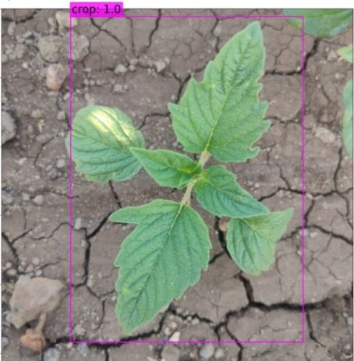 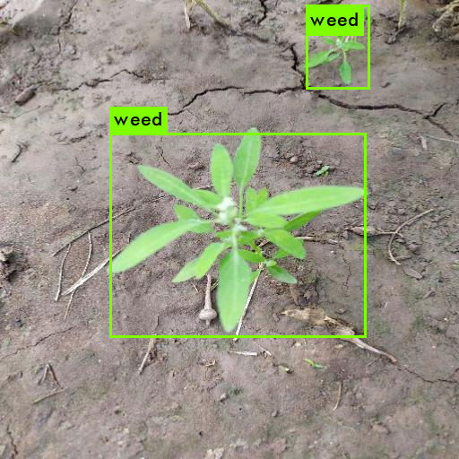

**Data:**

We using our dataset uploaded on [kaggle](https://www.kaggle.com/ravirajsinh45/crop-and-weed-detection-data-with-bounding-boxes). This dataset contains 1300 images of sesame crops and different types of weeds with each image labels. Each image is a 512 X 512 color image. Labels for images are in YOLO format. Data on <https://www.kaggle.com/ravirajsinh45/crop-and-weed-detection-data-with-bounding-boxes>

**Some Images:**

Sesame Crop

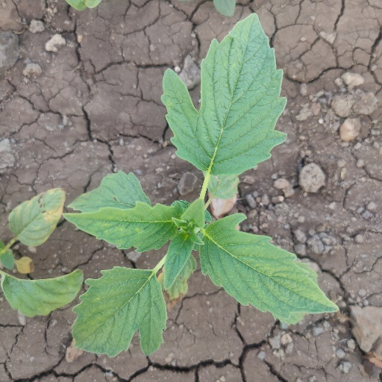 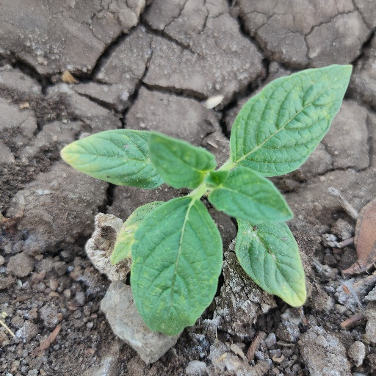

Weed

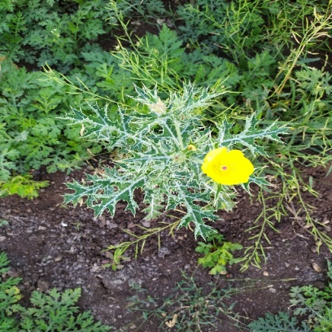 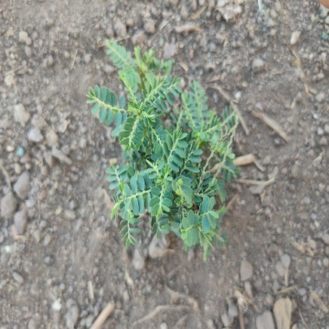 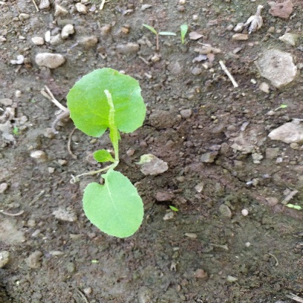

## Code submission (Github link) :

## 4.2 Report submission (Github link) :

## 

# Proposed Design/ Model

Implementing a crop and weed detection system using Data Science and Machine Learning involves several steps. Here's a high-level overview of the algorithm implementation process:

1. Data Collection and Preprocessing:

* Collect a dataset of images containing crops and weeds in various scenarios.
* Preprocess the images by resizing, normalizing, and augmenting them to enhance model generalization.

2. Feature Extraction:

* Extract relevant features from the images. For example, you can use color histograms, texture features, and edge detectors to capture distinctive characteristics of crops and weeds.

3. Model Selection:

* Choose a suitable machine learning algorithm. Convolutional Neural Networks (CNNs) are often used for image classification tasks due to their ability to learn hierarchical features.

4. Model Architecture:

* Design the architecture of the chosen model. For a CNN, this would involve stacking convolutional layers, pooling layers, and fully connected layers.

5. Data Splitting:

* Divide the dataset into training, validation, and testing sets. The training set is used to train the model, the validation set helps tune hyperparameters, and the testing set evaluates the final model performance.

6. Model Training:

* Train the selected model using the training data. During training, the model learns to differentiate between crop and weed images.

7. Hyperparameter Tuning:

* Fine-tune hyperparameters such as learning rate, batch size, and regularization strength to achieve the best model performance.

8. Model Evaluation:

* Evaluate the model using metrics like accuracy, precision, recall, F1-score, and confusion matrix on the validation and test sets. This helps you understand how well the model generalizes to unseen data.

9. Model Optimization:

* If the initial model doesn't perform well, consider adjusting the architecture, trying different optimization algorithms, or applying techniques like dropout and batch normalization to improve performance.

10. Deployment:

* Once you're satisfied with the model's performance, deploy it in a user-friendly interface or API that allows farmers to upload images and receive predictions.

11. Real-time Detection:

* In the deployment phase, ensure that the model can process images in real-time, providing instant feedback to users.

12. Continuous Improvement:

* As more data becomes available, consider retraining the model to further improve accuracy and robustness.

13. Documentation:

* Document the entire process, including data sources, preprocessing steps, model architecture, training details, and deployment instructions.

Keep in mind that the specific algorithms and techniques used will depend on the chosen machine learning framework, programming language, and the characteristics of your dataset. For image classification tasks, CNNs are widely used due to their ability to learn hierarchical features from images. Libraries like TensorFlow and PyTorch provide tools and resources for implementing CNNs and other machine learning algorithms efficiently.

## Block Diagram

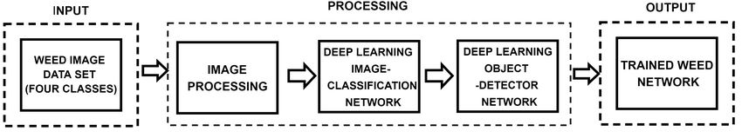

# Performance Test

The project of automated crop and weed detection using Data Science and Machine Learning goes beyond being just an academic endeavour and holds significant value for real industries, especially the agricultural sector. Here are several reasons why this work is well-suited for real industries rather than remaining solely an academic project:

1. Practical Problem Solving: This project directly addresses a practical challenge faced by the agricultural industry – the efficient management of crops and weeds. Real industries require solutions that can have a tangible impact on their operations and profitability. Automating crop and weed detection can lead to increased crop yields, reduced resource wastage, and better overall farm management.

2. Economic Benefits: Adopting automated crop and weed detection systems can lead to substantial economic benefits for farmers and agricultural companies. Increased yield due to timely intervention and optimized resource utilization translates to higher profits. Real industries are always seeking ways to enhance their bottom line, making this project highly relevant.

3. Efficiency and Sustainability: Modern industries, including agriculture, are under increasing pressure to adopt sustainable practices. The ability to precisely target herbicide application only where needed reduces chemical usage, minimizes environmental impact, and aligns with sustainability goals. This project directly contributes to more efficient and eco-friendly agricultural practices.

4. Technological Advancement: The agricultural industry is embracing technological advancements to address contemporary challenges. By integrating cutting-edge technologies like Data Science and Machine Learning, industries can demonstrate their commitment to innovation and competitiveness.

5. Industry Collaboration: Agricultural companies often collaborate with technology providers to develop and implement solutions tailored to their specific needs. Collaborative efforts between tech experts and industry professionals can lead to more effective and customized solutions that academic projects might not fully achieve.

6. Scalability and Deployment: Real industries require solutions that can be implemented on a larger scale. Developing a user-friendly interface, ensuring real-time processing, and deploying the system on various types of machinery (tractors, drones, etc.) are essential considerations for practical implementation. These aspects go beyond the scope of academic projects.

7. Real-world Data Challenges: Academic projects often work with curated and well-structured datasets. In real industries, data can be noisy, diverse, and challenging. Creating a solution that works robustly with such real-world data demonstrates its viability and relevance in practical scenarios.

8. Long-term Impact: Real industries are invested in long-term impacts and sustainability. Implementing a functional automated crop and weed detection system can lead to lasting benefits for the industry and farmers, ensuring its usefulness for years to come.

In conclusion, the project of automated crop and weed detection using Data Science and Machine Learning holds immense value for real industries, offering practical solutions to critical challenges in agriculture. Its potential to boost efficiency, improve profitability, and contribute to sustainable farming practices makes it well-suited for adoption by agricultural companies and organizations looking to stay competitive and aligned with evolving industry needs.

The project of automated crop and weed detection using Data Science and Machine Learning comes with several constraints that need to be considered and addressed to ensure its successful implementation. Here are some common constraints and strategies to overcome them:

1. Data Availability: Constraint: Availability of diverse and labeled data is crucial for training accurate machine learning models. Overcoming Strategy: Collect a representative dataset that covers various crops, weed species, lighting conditions, and growth stages. Data augmentation techniques can help expand the dataset. Collaborate with agricultural experts to ensure dataset diversity.

2. Imbalanced Classes: Constraint: The classes (crops vs. weeds) might be imbalanced in the dataset, leading to biased model training. Overcoming Strategy: Use techniques such as oversampling, undersampling, or generating synthetic data to balance the classes. Adjust class weights during training to give more importance to the minority class.

3. Environmental Variability: Constraint: Environmental conditions, lighting, and weather can affect image quality and appearance, impacting model performance. Overcoming Strategy: Use data augmentation to simulate various environmental conditions during training. Consider using domain adaptation techniques to make the model more robust to environmental variations.

4. Model Complexity: Constraint: Overly complex models might lead to overfitting and longer inference times. Overcoming Strategy: Opt for architectures that balance complexity and performance, such as pretrained CNNs. Regularization techniques like dropout and batch normalization can prevent overfitting.

5. Hardware Limitations: Constraint: Limited computational resources can hinder training and real-time inference. Overcoming Strategy: Utilize cloud-based resources for training and inferencing if local hardware is insufficient. Quantization and model compression techniques can reduce the model size without compromising accuracy.

6. Real-time Processing: Constraint: Real-time processing requirements demand efficient algorithms to provide timely feedback. Overcoming Strategy: Optimize the model for fast inference using techniques like model pruning, quantization, and efficient network architectures. Parallel processing and hardware acceleration can also enhance inference speed.

7. Interpretability: Constraint: Complex machine learning models might lack interpretability, making it difficult to understand the model's decisions. Overcoming Strategy: Use techniques like Grad-CAM, SHAP (SHapley Additive exPlanations), and feature visualization to provide insights into the model's predictions and highlight important regions in images.

8. Deployment Challenges: Constraint: Deploying the model on different platforms and integrating it into existing agricultural machinery can be challenging. Overcoming Strategy: Develop a user-friendly interface or API that abstracts the complexity of the model. Collaborate with hardware engineers to ensure seamless integration with different devices.

9. Ethical Considerations: Constraint: Automated systems should minimize unintended consequences, such as indiscriminate herbicide application. Overcoming Strategy: Implement fail-safe mechanisms and human oversight to prevent incorrect actions. Regularly update the model to account for new data and changing conditions.

By carefully considering these constraints and applying appropriate strategies, the project can navigate challenges effectively and deliver a robust and practical solution for automated crop and weed detection.

## Test Plan/ Test Cases and Test Procedure

Creating a comprehensive test plan and test cases is essential to ensure the quality and effectiveness of the automated crop and weed detection project. Here's a sample test plan outline along with test cases for various aspects of the project:

**Test Plan: Automated Crop and Weed Detection**

**1. Functional Testing:**

**1.1 Model Training and Performance:**

* Test the training process of the model using a subset of the dataset.
* Ensure the model converges and achieves reasonable accuracy on the validation set.

**1.2 Model Evaluation:**

* Evaluate the trained model's accuracy, precision, recall, and F1-score on the test dataset.
* Verify that the confusion matrix provides a clear understanding of true positive, true negative, false positive, and false negative predictions.

**1.3 Real-time Processing:**

* Test the model's ability to process images in real-time or near-real-time.
* Measure the inference time for various images and ensure it meets performance requirements.

**2. User Interface Testing:**

**2.1 Interface Design:**

* Verify that the user interface is intuitive and user-friendly.
* Ensure proper layout, responsive design, and easy navigation.

**2.2 Image Upload and Prediction:**

* Test image upload functionality to ensure images can be correctly uploaded.
* Verify that predictions are displayed accurately and in a timely manner.

**3. Robustness and Variability Testing:**

**3.1 Environmental Variability:**

* Test the model's performance under varying lighting conditions, weather, and environmental factors.
* Ensure the model remains accurate across different scenarios.

**3.2 Image Quality:**

* Test the model's ability to handle images with different qualities (blurry, low resolution, etc.).
* Verify that the model doesn't break down when presented with challenging images.

**4. Performance Testing:**

**4.1 Scalability:**

* Test the model's performance on larger datasets to ensure it can handle a significant number of images without crashing or slowing down.

**4.2 Hardware Resource Usage:**

* Measure CPU and memory usage during inference to ensure the system operates within acceptable resource limits.

**5. User Feedback and Acceptance Testing:**

**5.1 Usability:**

* Gather feedback from potential users (farmers, agricultural experts) about the user interface, ease of use, and overall satisfaction.

**5.2 Impact Assessment:**

* Monitor the impact of the system on crop management and resource utilization, gathering feedback on improvements in yield and reduced chemical usage.

**6. Ethical Considerations:**

**6.1 Avoiding False Positives:**

* Test the system's response to different levels of uncertainty and ensure that it avoids making incorrect predictions that might lead to unnecessary actions.

**6.2 User Override:**

* Verify that there is a mechanism for users to override the system's decisions if necessary.

**7. Documentation and Support Testing:**

**7.1 Deployment Documentation:**

* Verify that the deployment documentation is comprehensive and provides clear instructions for users to set up and use the system.

**7.2 Support and Troubleshooting:**

* Test the support mechanism to ensure users can reach out for assistance and troubleshooting.

**8. Security and Privacy Testing:**

* Ensure that user data, especially images, are stored and processed securely and that there are no vulnerabilities that could lead to data breaches.

**9. User Training:**

* If required, create user training materials and assess their effectiveness in helping users understand and utilize the system.

Remember, the above test cases are just a starting point. Customizing them to your specific project's requirements, adding more cases, and conducting thorough testing will help ensure that the project performs optimally in real-world scenarios.

## Performance Outcome

The performance outcomes of the project on automated crop and weed detection using Data Science and Machine Learning can be measured through various metrics. The specific metrics will depend on the objectives and priorities of the project, but here are some key performance indicators to consider:

1. Accuracy: This is a fundamental metric that measures the proportion of correctly classified instances (crops and weeds) among all instances. It provides a general overview of the model's overall performance.
2. Precision: Precision indicates the proportion of true positives (correctly detected crops or weeds) among all instances predicted as positive. It helps evaluate the model's ability to minimize false positives.
3. Recall (Sensitivity or True Positive Rate): Recall measures the proportion of true positives among all actual positive instances. It assesses the model's ability to avoid false negatives, i.e., missing actual crops or weeds.
4. F1-Score: The F1-score is the harmonic mean of precision and recall. It balances the trade-off between precision and recall and is useful when dealing with imbalanced classes.
5. Confusion Matrix: The confusion matrix provides a detailed breakdown of true positive, true negative, false positive, and false negative predictions. It offers insights into where the model is making correct and incorrect predictions.
6. ROC Curve and AUC: If applicable, the Receiver Operating Characteristic (ROC) curve and Area Under the Curve (AUC) score can evaluate the model's performance across different classification thresholds.
7. Computational Efficiency: Evaluate the model's inference time on new images. Real-time or near-real-time performance is crucial for practical implementation in agricultural settings.
8. Generalization: Test the model on unseen data or data from different fields to assess its ability to generalize to varying conditions and locations.
9. User Feedback and Satisfaction: If the project is deployed in real industries, gather feedback from users (farmers, agricultural professionals) to evaluate the system's usefulness, ease of use, and impact on their operations.
10. Reduction in Chemical Usage: If the project involves targeted herbicide application, measure the reduction in chemical usage compared to traditional blanket application methods.
11. Impact on Crop Yields: Monitor changes in crop yields and health after implementing the automated system. Assess whether the system contributes to increased yields and better crop management.

It's important to set specific goals and criteria for success based on the project's objectives and the industry's needs. Additionally, considering real-world challenges and constraints, the project's success should be evaluated not only in terms of metrics but also in terms of its practical feasibility, user acceptance, and economic impact on the agricultural industry.

# Future work scope

The project of automated crop and weed detection using Data Science and Machine Learning can open up several exciting avenues for future work and enhancements. Here are some potential areas to explore in future work:

1. Multi-Species Detection: Expand the system's capabilities to detect and differentiate between multiple crop species and various types of weeds. This could involve collecting and labeling data for a broader range of plants and training the model to handle diverse scenarios.

2. Disease and Pest Detection: Integrate disease and pest detection into the system. Develop models that can identify common plant diseases and pest infestations, allowing farmers to take proactive measures.

3. Adaptive Learning: Implement adaptive learning techniques where the model continuously updates itself with new data from the field. This ensures that the model remains accurate as environmental conditions change and new weed or crop varieties emerge.

4. Multi-Sensor Integration: Incorporate data from various sensors, such as infrared, hyperspectral, and thermal sensors, to enhance the system's ability to detect anomalies and differentiate between crops and weeds based on additional attributes.

5. Real-time Decision Support: Expand the system to provide more than just detection. Offer real-time recommendations for actions to take based on the detected crops and weeds, such as suggesting specific treatments or interventions.

6. Edge Computing: Explore deploying the model on edge devices like drones or tractors for on-site processing. This reduces the dependency on cloud resources and improves real-time responsiveness.

7. Hybrid Models: Experiment with hybrid models that combine the strengths of different machine learning techniques, such as using rule-based systems alongside deep learning models to enhance interpretability.

8. Transfer Learning: Utilize transfer learning by fine-tuning pre-trained models on your specific dataset. This can accelerate training and improve accuracy, especially when data is limited.

9. Explainable AI: Develop methods to explain the model's predictions, increasing user trust and making it easier for users to understand and act upon the system's insights.

10. User-Centered Design: Conduct usability studies and gather feedback from end-users to refine the user interface, ensuring it's intuitive and aligns with farmers' needs.

11. Robotic Integration: Integrate the crop and weed detection system with robotic platforms capable of targeted weed removal or other interventions. This would create an end-to-end solution for automated field management.

12. Long-Term Monitoring: Implement a system that can track the performance and impact of the solution over seasons, measuring changes in yield, resource utilization, and environmental factors.

13. Regulatory Considerations: Explore regulatory requirements for deploying automated systems in agriculture, considering factors like safety, data privacy, and compliance with industry standards.

14. Collaborative Networks: Engage with agricultural experts, researchers, and industry partners to collaboratively improve the system's accuracy, expand its features, and validate its impact.

As technology evolves and the agricultural industry continues to embrace innovation, there are numerous opportunities to advance the automated crop and weed detection project and make a lasting impact on sustainable farming practices.